Collecting a Custom Dataset for KWS

In this reading, we are going to walk through the steps for collecting a custom dataset for KWS!

**There is a change from the video below -- please only record 10 words per recording session as Chrome will only allow you to download 10 files at a time. We are working to debug the zip library which will allow us to get back to ~30 files per recording session.**

**If you would like to run the open-speech-recording application locally (and therefore not have a limit on simultaneous downloads) please see our**[**appendix document**](https://github.com/tinyMLx/appendix/blob/main/OpenSpeechRecordingLocal.md)**. Do note that you must be comfortable running python and python-pip from the command line to take this approach.**

If you record using your own tools make sure to name your files **keyword_###.ogg** where keyword is whatever word you are recording and ### is any integer number. This is needed for the training scripts to process your files correctly.

We are going to use a modified version of Pete’s [open-speech-recording project](https://github.com/petewarden/open-speech-recording) that will keep all of your recording data local to your browser (and thus it will never leave your computer)! You can open up the application in your browser by navigating to: <https://tinymlx.org/open_speech_recording/>.

Please make sure to open this application on a device that you can easily download and upload files from (e.g., a laptop as compared to a phone).

If you see a warning that says: Your device does not support the HTML5 API needed to record audio (this is a known problem on iOS).

* + 1. If you are not using Chrome, we suggest you switch to [Chrome](https://www.google.com/chrome/). We have tested all of our applications on Chrome and cannot guarantee compatibility with other browsers.
    2. Make sure you are navigating to https://. For some reason, if you do not use the secure protocol, then the HTML 5 API will not work.
    3. Make sure you approve access to your microphone! The first time you load the webpage (or if you load it again in an incognito window), you should get a popup on the top left of your screen as shown below. Make sure to click the “allow” button!

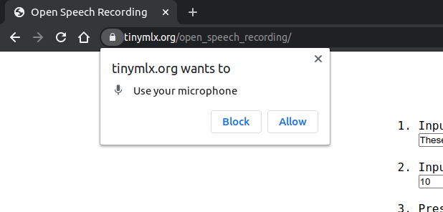

**Using the Open Speech Recording App**

* 1. In the middle of the screen, you will see the instructions for the App. Make sure you follow the steps in order. First, in step 1, type in **as a comma separated list**, the words you would like to record. And in step 2, type in **as a single integer**, the number of times you would like to record those words.

**Note that we have found that ~40 recordings each of 2-4 words often will be enough data to successfully train a moderately decent KWS application** (i.e., it will work for your voice in whatever exact room you are in but may not generalize beyond that and may only work well for some of the keywords).

Also, note that since all recordings will be saved in your browser memory and you can record multiple times by refreshing the page to reset the application, we do not suggest recording too many words in any one round of recording. **We have found that Chrome will only let you download 10 recordings per session. So do not try to record more than 10 words before refreshing the page.** Note that this is a change from the video as at the time of recording we were using a zip library that allowed ~30 words to be downloaded at a time. Unfortunately, that library, JSZip, now does not seem to be working. If you happen to be a web development guru and have ideas for a stable way to zip and download more files please do let us know!

As a final note, remember that you can record both keywords and other distractor words (e.g., if your keyword was “slow” you could also record “snow”) to help. refine the model.  
  
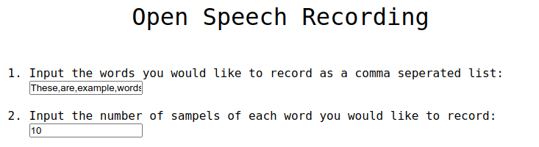

* 1. Then, click the blue record button. You will see a 3,2,1 timer countdown occur and then recording will start.

You will see a counter of X/Y appear that will show you your progress in recording all of the words. You will also see the current word you are supposed to record appear in the white box. The words will come shuffled in a random order, so sometimes they will alternate and sometimes, you will get the same word multiple times in a row. You will also see the waveform of your current speech appear in the grey box below that.

It may take you a couple of tries to get the exact timing working. As a tip, the “Record” button will alternate between grey (as shown below) and red. Record the word shown in the white box each time the word record turns red.

After each word is recorded, it will appear as a new row in the bottom of the screen.

You can pause the recording session by clicking “Stop” at any time. The “Stop” button will then turn grey and the “Record” button will turn blue again. Click “Record” to restart the recording session.

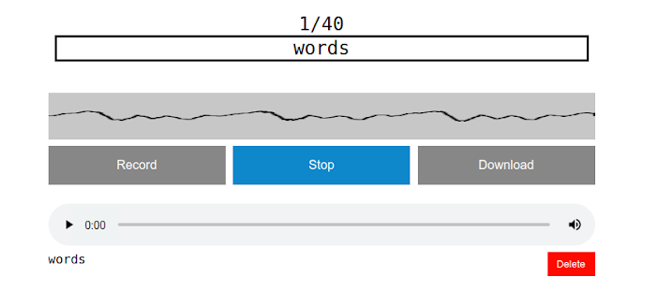

* 1. Once you complete recording the final word in this session, a pop-up will appear asking if you’d like to download your recordings now. If you are satisfied, click “OK” otherwise, click “Cancel” and you can inspect the recordings one by one and download them later.

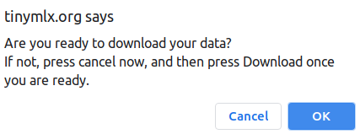

Note that if you use the application multiple times, you may get a pop-up asking for your permission to download multiple files. Click “Allow” and it should then automatically download all of your recordings again in the future without asking.

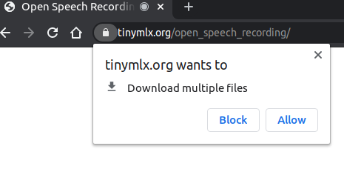

* 1. To inspect a recording, simply press the play button on the left of its row. You can delete any recordings you don’t like by clicking the red “delete” button on the bottom right of its row. You can also adjust the volume of the recording as you listen to it by using the speaker icon on the right of each row.

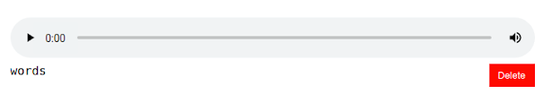

* 1. Once you have removed any recordings, you do not like simply click the “Download” button in the middle of the screen that will have turned blue. Note the warning mentioned above about Chrome needing approval to download multiple items.
  2. And that’s it! You’ve successfully collected a KWS dataset. Feel free to record multiple times if you’d like to increase the size of your dataset and remember where your files are being downloaded. If you happen to be recording at a time where your download is a single zip file (instead of many .ogg audio files), you’ll want to unzip all of your recordings to a folder from which you can upload them into the next Colab for training! On most operating systems, right-clicking a zip file will reveal an option that says either “extract” or “open archive manager” or something along those lines. Clicking that will either immediately unzip the files or open up a window which will have an option to unzip the files.